Advanced Thermodynamics and Phase Behaviour

Project 2

PRATEEK BHARDWAJ ( UTWID : PB22734)

**Problem 1 :**

**Program Code: Attached here and emailed**

**Program Description:**

The program comprises of the following function files and main file :

Main.m : Master File for inputs for Tc,Pc,w,number of components,overall composition and Binary Interaction Parameters. The following function files are used:

* PR_Para.n : Function to calculate Peng Robinson EOS parameters a,b,A,B etc.
* Cordano.m and cubic_roots.m : Function to solve cubic equation of state to find roots for compressibility factor.
* phiFixed.m : Function to find fugacity coefficient and compressibility factor (with root selection for minimum Gibbs Free Energy).
* stationaryPoint.m : Function to evaluate the stationarity equation using successive substitution method.
* TwoPFlash.m : Function to perform a two phase flash calculation for unstable phase from stability analysis, using successive substitution.

**Iterative Procedure and convergence criteria for STABILITY ANALYSIS :**

1. Compute phi(Z) and compressibility factor(with root selection for minimum Gibbs Free Energy) for fixed composition Zi.(phiFixed.m)
2. Obtain initial estimate for Xi=Zi*Ki(vapour like phase) where Ki is calculated from Wilson’s correlation.
3. Calculate mole fractions using xi=Xi/sum(Xi).
4. Compute phi(x) and compressibility factor((with root selection for minimum Gibbs Free Energy) for composition xi.
5. The stationary points are found by the following criteria , which iteratively updates Xi and hence compositions xi until a stationary point is found using the following convergence criteria :

while norm(criteria) > tol && iter <= maxIter

criteria =abs(log(Xi.* phi(x))-log(Zi* phi(Z))) << *convergence criteria*

Xiiter+1= ((Zfixed.*phiZfixed)./(phi))iter  << *iterative update*

iter = iter +1

*Here tol=user specified tolerance, maxIter=user specified maximum iterations.*

1. If stationary point is found :
   1. Check for trivial solution by norm(abs(xi-Zi))< 1e-8. If the solution is trivial, move to second estimate for Xi=Zi/Ki(liquid like phase).
   2. Check for stability using sum(Xi) criteria
      1. If sum(Xi)>1, the solution is unstable and proceed to two phase flash calculation
      2. If sum (Xi)<1, solution is stable at the found composition, move to second estimate for Xi=Zi/Ki(liquid like phase).
2. Obtain second initial estimate for Xi=Zi/Ki(liquid like phase), where Ki is calculated from Wilson’s correlation.
3. Repeat steps 3 to 5.
4. If stationary point is found :
   1. Check for trivial solution by norm(abs(xi-Zi))< 1e-8. If the solution is trivial. Stop the program.
   2. Check for stability using sum(Xi) criteria
      1. If sum(Xi)>1, the solution is unstable and proceed to two phase flash calculation
      2. If sum (Xi)<1, solution is stable at the found composition, stop program. The mixture is stable.

**Iterative Procedure and convergence criteria for TWO PHASE FLASH:**

1. Obtain initial estimate for Ki value from Wilson correlation
2. Calculate xi,yi, and V from Rachford-Rice equation
3. Calculate the Peng Robinson cubic equation parameters for vapour phase using mole fraction yi and for liquid phase using mole fraction xi
4. Compute and compressibility factor((with root selection for minimum Gibbs Free Energy) and phiiL and phiiV
5. Check for convergence based on residuals of the fugacity equation. This is done as follows :

while (norm(criteria)>tol) && (iter< maxIter)

criteria=abs(log(x.*phiZL)-log(y.*phiZV)); << *convergence criteria*

Kiter+1= (exp(log(phiZL)-log(phiZV))) iter  << *iterative update*

iter=iter+1;

*Here tol=user specified tolerance, maxIter=user specified maximum iterations.*

1. If convergence is achieved, return the phase compositions and stop. Otherwise continue the process iteratively by updating K values as given above in the while loop.

**Problem 2:**

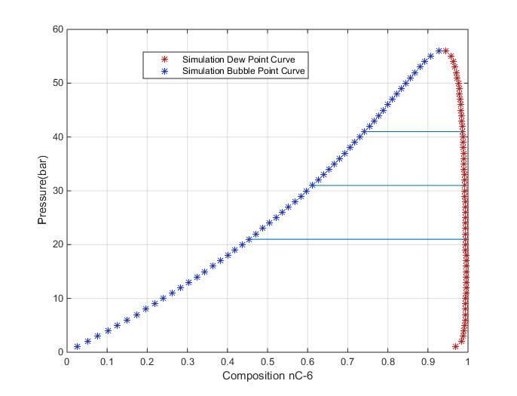2 a: The bubble point and dew point curves obtained from two phase flash code at 621.8K. The tie lines obtained from the PT flash are shown in the P-x diagram. The tie lines are generated in the code submitted for this question. (Q2c.m in folder Pr2_Q2)

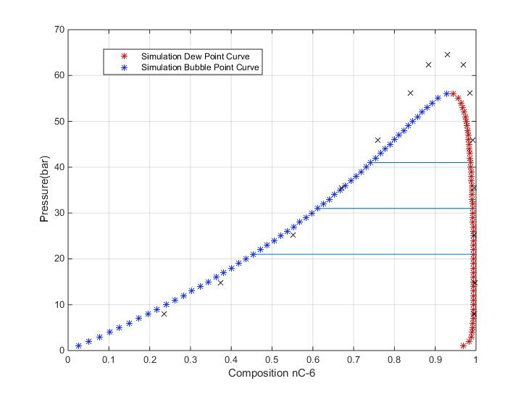2 b: The corresponding pressure composition date from the paper by Joyce et al.(2000) is plotted on the plot from part a . This is labeled as crosses (x: measured data) (Q2b.m in folder Pr2_Q2)

x measured data

2 b: The BIP was changed from 0 to 0.099 between nC6 and nC36. This value was selected to obtain a better represent the critical point of the system which is given in Joyce et al.(2000) at P=64.51 bar. (Q2c.m in folder Pr2_Q2). The pressure intervals were reduced to better capture the critical point and maximum number of iterations were also increased to capture near critical point values.

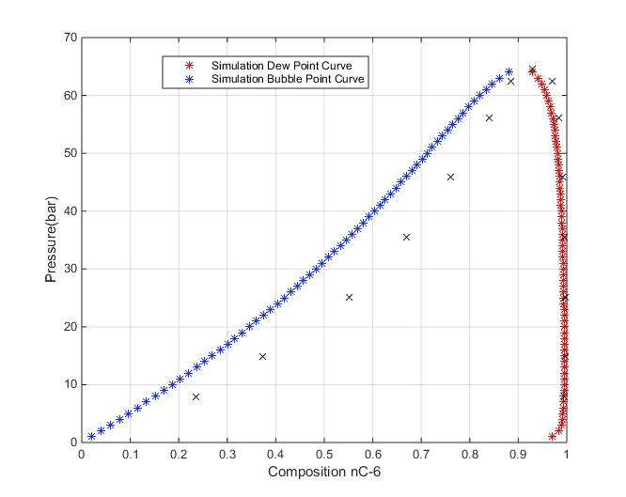

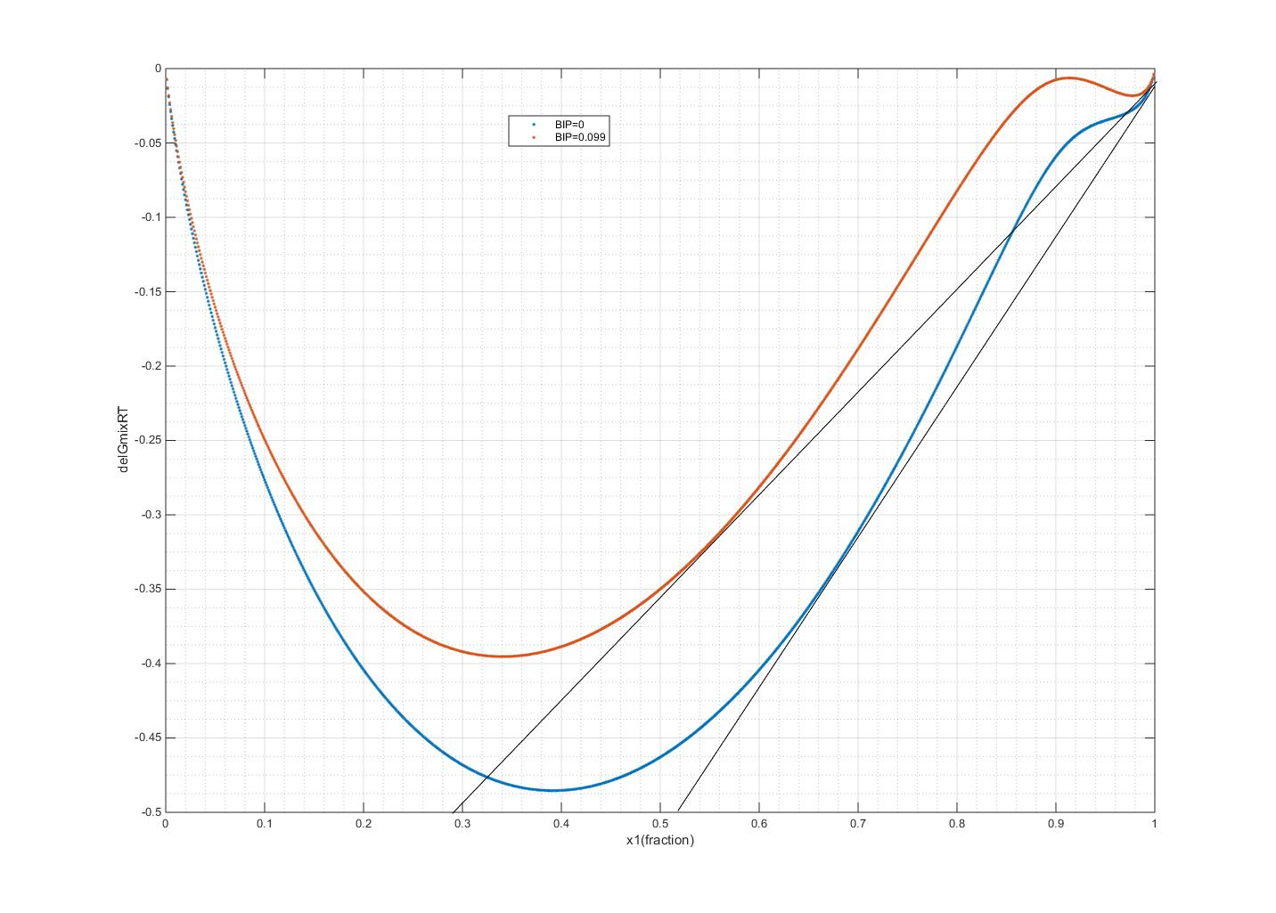2d: Dimensionless Gibbs free energy change of mixing is plotted for both case from part 2a and part 2c in composition space at a pressure of 35.49 bars. The effect of BIP on phase envelop and Gibbs energy is seen from figures 2b, 2c and 2d. Increasing the binary interaction parameter decreases the attraction parameters since aij=aiaj* sqrt(1-Kij). Since dimensionless GFE of mixing shows deviation from ideal behavior, increasing BIP to a positive non-zero value, moves the curve upwards, or towards ideal behavior. The phase envelop shifted upwards and leftwards in P-x space.

**Problem 3:**

3a. : K values and corresponding overall compositions for the tie lines are:

|  |  |  |  |  |
| --- | --- | --- | --- | --- |
|  |  | CO2 | nC4 | nC10 |
| K-Values | = | 1.3815 | 0.4439 | 0.0653 |
| K-Values | = | 1.29180 | 0.52178 | 0.11162 |
| K-Values | = | 1.2565 | 0.5579 | 0.1397 |
| K-Values | = | 1.19480 | 0.63123 | 0.21147 |
| K-Values | = | 1.1341 | 0.7198 | 0.3292 |
| K-Values | = | 1.0511 | 0.8765 | 0.6405 |

|  |  |  |  |  |
| --- | --- | --- | --- | --- |
|  |  | CO2 | nC4 | nC10 |
| Zi | = | 0.7500 | 0.0500 | 0.2000 |
| Zi | = | 0.91000 | 0.06000 | 0.03000 |
| Zi | = | 0.8000 | 0.1000 | 0.1000 |
| Zi | = | 0.85000 | 0.10000 | 0.05000 |
| Zi | = | 0.8500 | 0.1100 | 0.0400 |
| Zi | = | 0.8400 | 0.1220 | 0.0380 |

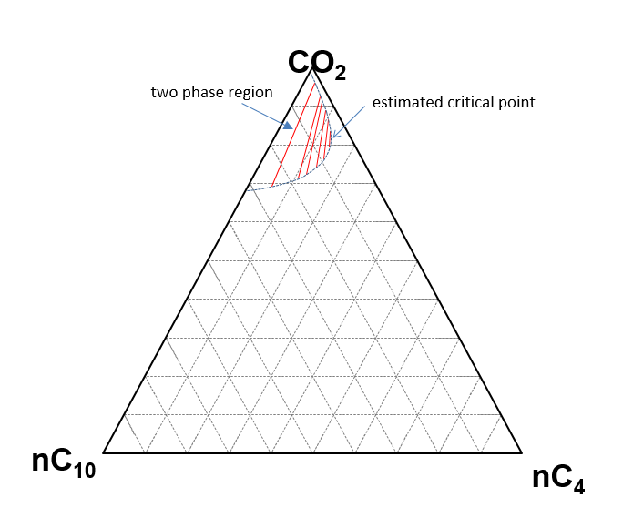

3b.: Let gamma be the mixing ratio. The equilibrium phases compositions for overall composition 80% CO2. 10% nC4 and 10% nC10 are :

Vapour Fractions = 0.9106 0.0680 0.0214

Liquid Fractions = 0.7247 0.1218 0.1535

Analytical calculation of the composition on the two edges is on the next page. (P.T.O).The two edge compositions are :

CO2 nC4 nC10

0.940672 0.059327 0

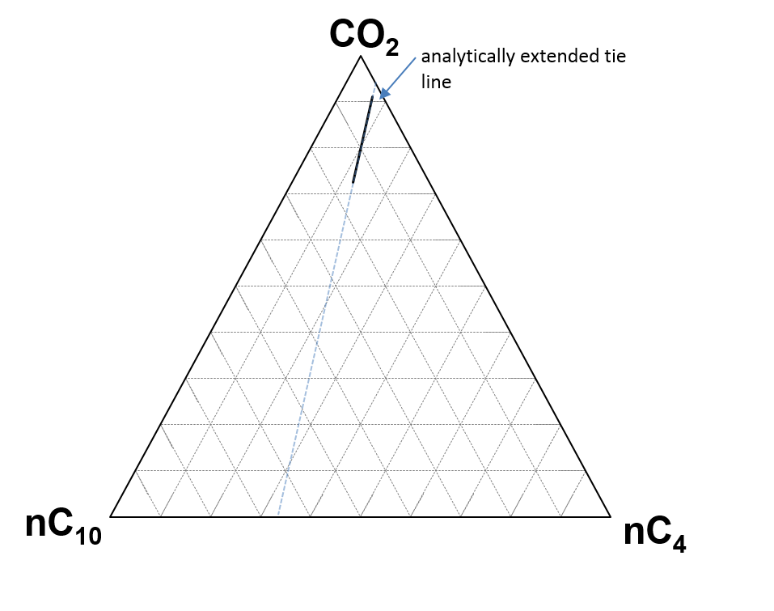0 0.331388 0.668611

The G/RT plot is plotted below. Confirmation that they have a common tangent line on the Gibbs free energy plot is obtained using first derivative plot. On the first derivative og G/Rt plot the gamma calculated below have equal values. This implies that the tangent is common, since the first derivative represents the tangent.

equilibrium conc. at gamma = 0.7704

Zi = 0.72469 0.12179 0.15351

equilibrium conc. at gamma = 0.968

Zi = 0.91057 0.068033 0.021396

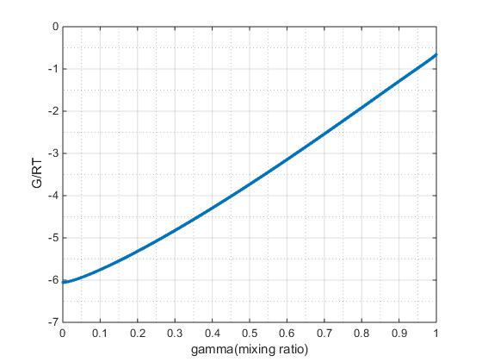

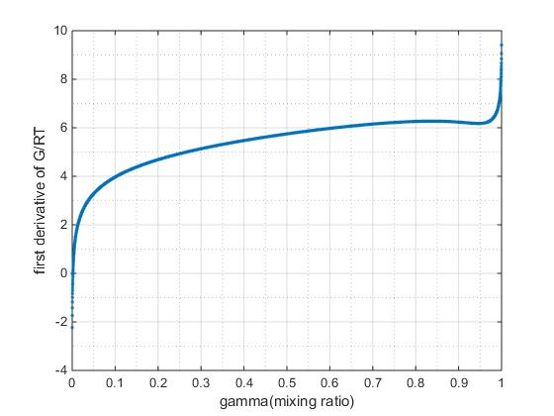

0.7704 0.968

first derivative at gamma 0.770 = 6.2376

first derivative at gamma 0.968 = 6.2379

Note : These are numerically equal values and precision of the derivative depends on the interval of gamma. In this case interval is 0.0001.